

**Whitburn Community Centre Programme**

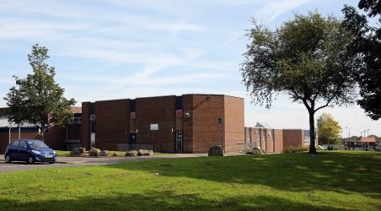

**TEL: 01501 678888**

**EMAIL: whitburncecentre@yahoo.co.uk**

**FACEBOOK: YourWhitburnCECentre**

**Tuesday**

**Basic I.T Course 9.00-12.00**

**50+ Keep Fit 9.30-11.00**

**Rural Sewing 10.00-12.00**

**81 Club 13.00-15.00**

**Silver Skill Seeker 14.00-16.00**

**5 a sides football 18.00-21.00**

**Adult Basic English 19.00-21.00**

**Monday**

**Whitburn Outreach 9.00-16.00**

**Peer Recovery 10.30-13.00**

**81 Club 13.00-15.00**

**Market Inn Football 18.10-19.10**

**Mime & Drama 18.30-21.30**

**P.C Passport 19.00-21.00**

**Fatburn Extreme 19.30-20:00**

**Sewing Group 19.00-21.00**

**Thursday**

**The Walking Football 10.30-12.30**

**81 Club 13.00-15.00**

**5 a sides football 17.00-20.00**

**Judo 18.00-21.30**

**P.C Passport 19.00-21.00**

**ACE 19.00-21.00**

**Wednesday**

**Playbuddies 9.30-11.30**

**50+ Dancing 13.0015.30**

**81 Club 13.00-15.00**

**IT Course 13.00-15.00**

**Taekwondo 16.00-17.00**

**West Lothian Youth 16.00-17.00**

**Foundation (WLYF)**

**Fatburn Extreme 18.30-19.00**

**Youth Club 19.00-21.00**

**Judo 18.30-21.30**

**Saturday**

**Soccer School 10.00-11.00**

**Friday**

**After School Club 13.30-15.30**

**(P3-P6)**

**Youth Club 19.00-21.00**

**N/A Meeting 19.00-20.00**

**Sunday**

**Football Buzz 10.00-12.00**

**5 a sides football 16.30-21.30**

**Judo 18.00-21.30**



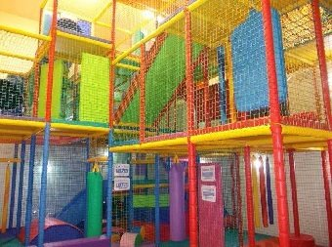

**For babies, toddlers & children ages upto P7!**

**Soft Play Prices**

**Centre member—£1**

**Non member—£3**

**Become a member & save money!**

**See reception for more information**

**Soft Play Opening Times**

**Monday-Friday-9.00-19.00**

**Saturday-9.00-16.00**

**Sunday –10.00-19.00**

**Soft Play & various rooms available for Children’s Birthday Parties**

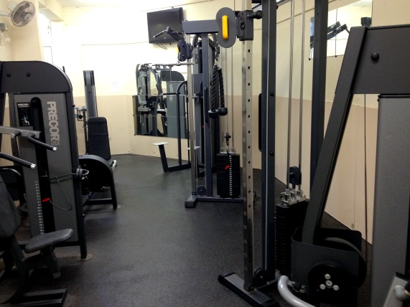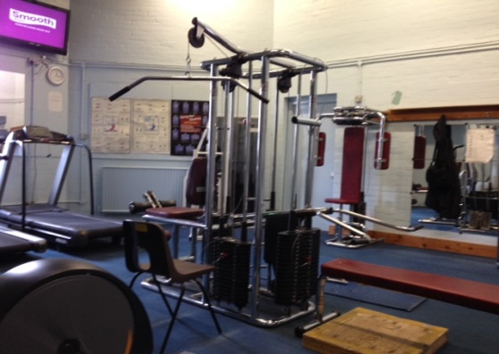

**Remember & register at**

**www.mygov.scot/my-account**

**Thanks & enjoy!**

**Monday– Friday -8.30-21.15**

**Saturday 9.00– 17.45**

**Sunday– 9.30-21.15**

**Both membership card & gym card must be shown**

**Prices Non Members:**

**Standard Party-£42**

**Soft Play Party-£60**

**Sports Hall & Art Room-£62**

**Prices Members:**

**Standard Party-£21**

**Soft Play Party -£30**

**Sports Hall & Art Room-£31**