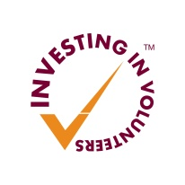
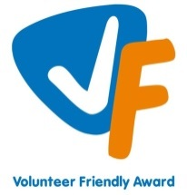



West Lothian Council Advice Shop
Volunteer Role Description – Volunteer Driver

Role Title: | Driver
Responsible to: | Volunteering Team
Location: | Bathgate Partnership Centre
Time Commitment: | Negotiable, minimum 3 hours per week.
Role Description: | West Lothian Council Advice Shop is part of the new Anti - Poverty Service and provides help and advice to customers regarding a wide range of welfare benefit and other enquires. Many of our clients are experiencing financial hardship and require support from River Kids Charity (Broxburn). We are looking for volunteers to collect parcels from River Kids and School Clothing Bank and deliver to families within West Lothian.
What’s involved | Collect parcels from the River Kids service in Broxburn and School Clothing bank in Livingston  Liaise with Advice Shop staff for delivery information  Deliver parcels to families  Liaise with Advice Shop staff to confirm deliveries made  Maintain confidentiality regarding customer information.
What skills are required? | Good communication, listening and interpersonal skills  Highly reliable  Able to work independently and as part of a team  Good understanding of the importance of client confidentiality  Commitment to the work of the Advice Shop
What training and support is offered | Classroom based training includes:  Induction  Ongoing training  One to one and group support provided  All training and meetings will take place in Bathgate Partnership Centre and it is likely that the time commitment will be greater during initial training.
Any other information | Car essential (travel expenses will be paid)  Must have valid driving licence, business use included in insurance and current MOT  Non-judgemental approach  Requirement to adhere to West Lothian Council policies and procedures, e.g. confidentiality, Protection of Vulnerable Groups etc.  Willingness to sign Volunteer Agreement, including confidentiality agreement.
Recruitment Process: | Information Session, Application Form, interview, references

