**Homeworking Risk Assessment**

**To be completed by employees who wish to work from home under the provisions of the Supporting Flexible Working Policy. Please read each question carefully and select 'yes' or 'no' answer and then make a note of any action taken by you to remove or reduce the risk, where appropriate. When complete please forward the assessment (treat as confidential and sensitive) to your line manager who will review the answers and verify compliance with statutory and organisational requirements.**

|  |  |  |  |  |  |  |
| --- | --- | --- | --- | --- | --- | --- |
| Name of employee working from home: | |  | | | Date: |  |
|  | | | | | | |
| Area in the home where you intend to work? | | |  | | | |
|  | | | | | | |
| Home Address: |  | | | Postcode: |  | |
| Tel: |  | |
| On average what is your normal commuting time (single journey) between your home and council work location? | | | | | | |

|  |  |  |
| --- | --- | --- |
| **CARDINUS DISPLAY SCREEN EQUIPMENT ASSESSMENT AND TRAINING** | | |
|  | | |
| Have you completed your display screen equipment assessment on [Cardinus](https://online.cardinus.com/PACE/WLC/Ergo/AdminSecurity/Account/Login)? | Yes | No |
|  | | |
| Have you completed your display screen equipment training on [Cardinus](https://online.cardinus.com/PACE/WLC/Ergo/AdminSecurity/Account/Login)? | Yes | No |
|  | | |
| *If you selected ‘No’ to any question, these should be completed. Once the assessment and training have been completed forward training certificates with this assessment to you line manager.* | | |

|  |  |  |
| --- | --- | --- |
| **DESK AREA** | | |
|  | | |
| Is your work desk large enough to accommodate all your work equipment? | Yes | No |
|  | | |
| Is there enough space underneath your desk to move and stretch your legs (no obstacles)? | Yes | No |
|  | | |
| If you selected No to any question what action(s) are required to minimise the risks involved? | | |
|  | | |

|  |  |  |  |  |  |
| --- | --- | --- | --- | --- | --- |
| **WORKSTATION SETUP** | | | | | |
| *For portable equipment such as laptops the main work station should be equipped with a riser or docking station , a separate screen, keyboard and mouse. The main work station will be where you work for the greatest percentage of the working week. For other work stations a riser, separate keyboard and mouse should be used.* | | | | |
| Is your monitor/screen positioned to prevent glare from natural or artificial light sources? | | Yes | No | |
|  | | | | |
| Is your keyboard and mouse easily reached? | | Yes | No | |
|  | | | | |
| Are you able to adjust the height of your monitor (top of screen should be at eye level)? | | Yes | No | |
|  | | | | | |
| *Note: This is important as it encourages good posture and prevents musculoskeletal injuries.* | | | | | |
|  | | | | | |
| Are you able to reach all equipment without overstretching, twisting or straining your upper body? | Yes | | No | | | |
|  | | | | | | |
| Can your chair be adjusted in height, back adjustment and move freely on the floor without restriction? | Yes | | No | | | |
|  |  | | |  | |
| Do you have any concerns with your workstation setup which your manager needs to be aware of? | | | | | |
|  | | | | | |

|  |  |  |  |  |  |  |
| --- | --- | --- | --- | --- | --- | --- |
| **WORKING ENVIRONMENT** | | | | | | |
| *Your working environment is really important and your manager needs to know you’re comfortable and safe.* | | | | | | | |
|  | | | | | | | |
| Are there any cables lying on the floor which could get damaged or cause a tripping hazard? | Yes | | No | | | | |
|  |  | |  | | | | |
| Is your working area free from any slip or trip hazards? | Yes | | No | | | | |
|  | | | | | | | |
| Are levels of heat in the work area comfortable? | Yes | | No | | | | |
|  | | | | | | | |
| Please indicate how your work area is heated: | | | | | | | |
| Central Heating | |  | | |  |
| Supplementary heating (e.g. portable heater plugged into a power source) | |  | | |  |
|  | | | | | | | |
| Is your work area well-lit? (natural or artificial lighting) | Yes | | No | | | | |
|  | | | | | | | |
| Is your area well ventilated? (e.g. open windows) | Yes | | No | | | | |
|  | | | | | | | |
| Do you have any concerns with your work area which your manager needs to be aware of? (please specify below) | Yes | | No | | | | |
|  |  | | |  | | | |
|  | | | | | | | |

|  |  |  |
| --- | --- | --- |
| **ACCESS AND EGRESS (GETTING TO AND FROM YOUR WORK AREA)** | | |
|  | | |
| *When working from home, your home effectively becomes your workplace, and as such your manager needs to know that you have safe access to and egress from your workplace at all times. This would include work areas that have been set up out with the main home such as sun rooms or sheds.* | | |
|  | | |
| Do you have safe access to and from your place of work? e.g. free from risks of slip, trips and falls. | Yes | No |
|  | | |
| During adverse weather conditions do you maintain safe access / egress? e.g. if you have to go outside to access your work area or have to leave home to travel as part of your working day. | Yes | No |
|  | | |
| Are there any other concerns with access / egress which your manager needs to be aware of? e.g. unstable ladder to loft | Yes | No |
|  | | |
| Please add detail if access / egress from your home (workplace) gives you a cause for concern? | | |
|  | | |

|  |  |  |  |  |  |  |  |
| --- | --- | --- | --- | --- | --- | --- | --- |
| **FIRE SAFETY** | | | | | | | |
|  | |  | | | | |  | |
| Do you have smoke / heat detectors installed in your home? | | | | Yes | | No | | |
|  | | | | | | | | |
| If Yes to the above, are they tested regularly to ensure they are working? | | | | Yes | | No | | |
|  | | | | | | | | |
| There is a legislative requirement to have all smoke and heat detectors interlinked? Do your detectors comply with this requirement? (e.g. one activates, they all activate) | | | | Yes | | No | | |
|  | | | | | | | |
| Are good housekeeping practices employed in your work area to keep combustible materials to the minimum? | | | | Yes | | No | | |
|  | | | |  | | |  | |
|  |  | |  | | N/A | | | |
|  | |  | | | | |  | |
| If you do use supplementary heating equipment, is it: | | | | | | | | |
|  | | | | | | | | |
| Stable and cannot topple over? | | | | Yes | | No | | |
|  | | | |  | |  | | |
| Located away from combustible materials? | | | | Yes | | No | | |
|  | | | | | | | | |
| Visually checked regularly to verify it’s safe for continued use? | | | | Yes | | No | | |
|  | | | | | | | | |
| Plugged in to a singular socket (not in a cable extension with other items) | | | | Yes | | No | | |
|  | | | | | | | |
| In an emergency situation are you able to evacuate your workplace to a safe area, easily and without obstruction? | | | | Yes | | No | | |
|  | | | | | | | |
| Do you have any concerns about fire safety at home which your manager needs to be aware of? | | | | | | | |
|  | | | | | | | |

|  |  |  |
| --- | --- | --- |
| **ELECTRICAL SAFETY** | | |
| *Please see overloading of sockets guidance overleaf.*  Has your electrical work equipment been Portable Apparatus Tested (PAT)? | Yes | No |
|  | | |
| Do you carry out regular examinations of your work equipment to look for defects or damage? | Yes | No |
|  | | |
| Are you aware of what to do if you identify a concern with electrical work equipment? | Yes | No |
|  |  |  |
| If you use an extension cable at your workstation can you verify it is not overloaded or connected to another extension cable (piggy backing)? | Yes | No |
|  | | |
| Is your home fixed electrical system in good condition (e.g. no damaged sockets or wiring)? | Yes | No |
|  | | |
|  | | |

|  |
| --- |
| Do you have any concerns about electrical safety at home which your manager needs to be aware of? |
|  |

|  |  |  |
| --- | --- | --- |
| **LONE WORKING** | | |
|  | | |
| Will you be regularly lone working whilst at home? (e.g. working from home on your own, no one else in the house) | Yes | No |
|  |  |  |
| If yes, your manager will ensure the appropriate risk assessment is completed or updated. | |  |
|  | | |

|  |  |  |  |
| --- | --- | --- | --- |
| **PERSONAL SAFETY CONSIDERATIONS** | | | |
|  |  |  |
| Do you have a medical condition or impairment for which you need additional support or consideration by your line manager? | Yes | No |
|  | | |
| Do you require any specialist equipment to work from home? (e.g. as a result of an Occupational Health assessment) | Yes | No |
|  |  |  |
| Are you currently taking medication that may impair your mobility in an emergency situation, or place you at greater risk if you are a lone worker? | Yes | No |

|  |  |  |  |  |  |  |  |  |  |  |  |
| --- | --- | --- | --- | --- | --- | --- | --- | --- | --- | --- | --- |
| **EMPLOYEE WELLBEING** | | | | | | | | | | | |
| ***Looking after mental health and wellbeing is important. This includes staying connected with colleagues, establishing healthy working routines and having a productive working environment. It is also important that you know how to access support if needed.*** | | | | | | | | | | | |
|  |  | |  | | |  | | |  | | |
| Do you have the opportunity for regular contact with your line manager and colleagues, as needed? | | | | | Yes | | | No | | |
|  | | | | | | | | | | | |
|  | **Daily** | | **Weekly** | | **Monthly** | | | |
|  | | | | | | | | | | | |
| Emails | |  | |  | | |  | | |  |
| Phone calls | |  | |  | | |  | | |  |
| Microsoft Teams | |  | |  | | |  | | |  |
| In person | |  | |  | | |  | | |  |
| Other (please state) |  | | | | | | | | | | |
|  | | | | | | | | | | | |
| Do you take regular breaks from screen work? | | | | | Yes | | | No | | |
|  | | | | | | | | | | | |
| Regular breaks from screen work can reduce eye strain. You should aim to take at least 5 minutes break from screen work every hour, even if it’s just to stretch the legs or get yourself a glass of water. | | | | | | | | | | | |
|  | | | | | | | | | | | |
| Are you able to finish work at the end of the working day? (e.g. not carry on working into your own personal / family time) | | | | | Yes | | | No | | |
|  | | | | |  | | |  | | |
| Are you aware of the Council’s [Four Pillars of Wellbeing Toolkit](https://intranet.westlothian.gov.uk/article/43633/Four-Pillars-of-Wellbeing-Toolkit)? | | | | | Yes | | | No | | |
| Do you know who to report any personal wellbeing concerns or issues to? | | | | | Yes | | | No | | |
|  | | | | | | | | | | |
| Do you have any concerns about your mental health which your manager needs to be aware of? | | | | | | | | | | | |
|  | | | | | | | | | | | |

|  |  |  |
| --- | --- | --- |
| **RESPONSIBILITY FOR DEPENDANTS** | | |
| It is important that you are not responsible for dependants while undertaking work for the council.  There should be another responsible person available to attend to the needs of dependants during normal working hours. | | |
| Are arrangements in place for the care of dependants by another responsible person during normal working hours? | Yes | No |
| Do you have any concerns regarding responsibility for dependants which your manager needs to be aware of? | Yes | No |
| *If you selected “yes” please add detail of areas of concern.* | | |
|  | | |

|  |  |  |  |
| --- | --- | --- | --- |
| **Home Insurance Cover** | | | |
| *Council work equipment is covered by the Council’s insurers*  Have you advised your current home insurer that you are working from home? | Yes | No |
|  | | |
| If Yes, have they placed additional restrictions, limitations or advised you about other considerations in terms of your policy cover? | Yes | No |
|  | | | |
| If you selected Yes, please detail what these are? | | | |
|  | | | |

|  |  |  |  |  |
| --- | --- | --- | --- | --- |
| **Internet / Intranet Connectivity** | | | | |
|  | | | | |
| Do you have a stable broadband connection with sufficient upload / download speeds to allow smooth transfer of information? | Yes | No | |
|  |  |  | |
| Are you aware of how to contact the Council’s IT Service for support with remote working? | Yes | No | |
|  | | | | |
| Is your broadband connection to your pc / laptop by means of a: |  | |  | |
|  | | | | |
| Wireless connection | Yes | | No | |
|  | | | | |
| Ethernet cable | Yes | | No | |
|  | | | | |
| Do you have concerns about your connectivity that your line manager needs to raise with the IT Service? | | | | |
|  | | | | |

|  |  |  |
| --- | --- | --- |
| **SECURITY / DATA PROTECTION** | | |
| *Data protection must be given a high priority at all times.* | | |
|  | | |
| Are you familiar with your responsibilities in relation to data protection procedures and IT user security procedures? | Yes | No |
| Are you able to make arrangements in your home to comply with data protection and security measures? | Yes | No |
| Do you have concerns about security/ data protection whilst working at home? | | |
|  | | |

|  |  |  |
| --- | --- | --- |
| **ACCIDENT / INCIDENT REPORTING** | | |
| *It’s important events that have led to or had the potential to lead to personal injury or damage are reported*. | | |
|  | | |
| Are you aware of how to report accidents or incidents whilst working from home? | Yes | No |
|  | | |
| Are you aware of how to access [Sphera](https://intranet.westlothian.gov.uk/incident-recording) to report an incident/ accident/ near miss? | Yes | No |
|  | | |
| Are you aware you must report hazards within your working environment to your line manager as quickly as possible? | Yes | No |
|  | | |
| *Note: All accidents / incidents must be recorded in Sphera within three working days of the event occurring.* | | |
| Do you have concerns or queries about accident / incident reporting whilst working from home? | | |
|  | | |

|  |  |  |
| --- | --- | --- |
| **HOME WORKING TRAINING REQUIREMENTS** | | |
|  | | |
| *It’s important that home workers have a suitable level of training to assist them in maintaining a comfortable and safe working environment in their home.* | | |
|  | | |
| Please indicate which training you require: |  |  |
|  | | |
| Sphera accident / incident reporting | Yes | No |
|  | | |
| Musculoskeletal awareness | Yes | No |
|  | | |
| Electrical Safety | Yes | No |
|  | | |
| Fire Safety Awareness | Yes | No |
|  | | |
| DSE Awareness (in addition to Cardinus training) | Yes | No |
|  | | |
|  | | |
| *Please provide a picture of your workstation setup at home in the box below* | | |

|  |
| --- |
| Place picture of your workstation here |

**WORKSTATION PICTURE**

|  |
| --- |
| **EMPLOYEE DECLARATION** |

I declare the information provided is true and correct.

I understand the contents of this assessment will be disclosed to management, human resources and health and safety (where necessary) for further assessment and approval of my suitability for homeworking.

|  |  |  |  |
| --- | --- | --- | --- |
| Signature: |  | Date: |  |

|  |  |  |
| --- | --- | --- |
| **LINE MANAGER DECISION** | | |
|  | | |
| The employee’s DSE and workplace arrangements appear to be satisfactory | Yes | No |
|  | | |
| If No, please record what actions are needed: | | |
|  | | |
|  | | |

|  |  |  |
| --- | --- | --- |
| **Line Managers Details** | | |
|  | | |
| Name: | |  | | Signature: | ­­­­­­­­­­­­­________________________________ |
|  | | |
| Date: |  | |

|  |  |
| --- | --- |
| Record filed in: |  |

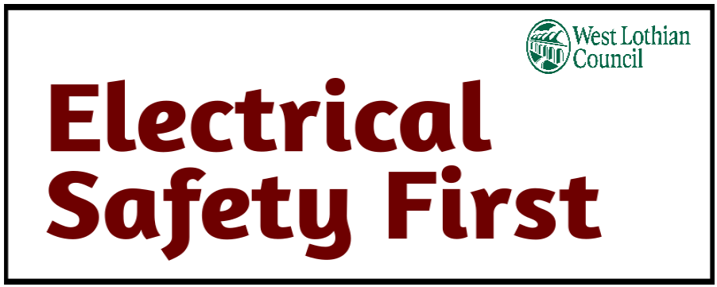

**Overloading electrical sockets**

Most people have extension leads in their homes, using 4-way bar adaptors to increase the number of appliances that they can plug into a wall socket.

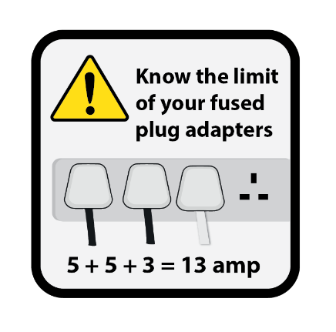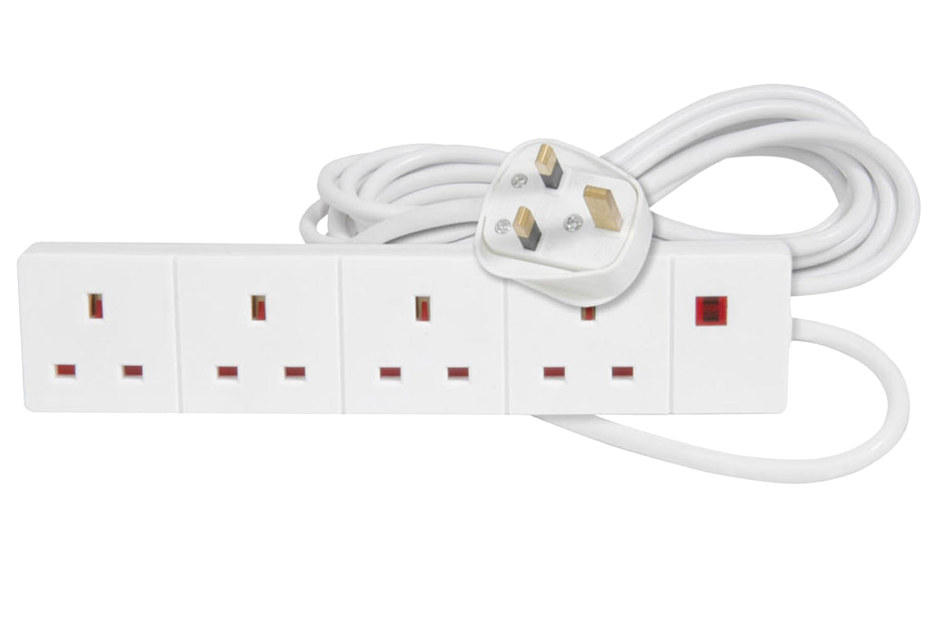However, although there is space to plug in four appliances, this does not mean it is always safe to do so.

**You can avoid overloading sockets and risk of fire by following this simple advice:**

* Check the current rating of the extension lead before plugging appliances into it. Most are rated at 13 A, but some are rated at only 10 A or less - the rating should be clearly marked on the back or underside of the extension lead. If not, refer to the manufacturer’s instructions.
* Never overload an extension lead by plugging in appliances that together will exceed the maximum current rating stated for the extension lead. This could cause the plug in the wall socket to overheat and possibly cause a fire.
* Use our overload calculator (below) to check if you’re exceeding the maximum load

<https://www.electricalsafetyfirst.org.uk/guidance/safety-around-the-home/overloading-sockets/>

# C:\Users\patterson.jim\AppData\Local\Microsoft\Windows\INetCache\Content.MSO\F67EA6DB.tmp

# Musculoskeletal disorders

The council has a duty to protect you from the risks of musculoskeletal disorders (MSDs) being caused or made worse by work. The parts of the body most likely to be affected by MSDs are:

* [the lower back](https://www.hse.gov.uk/msd/backpain/index.htm)
* [shoulders, forearms, wrists and hands, as well as the neck](https://www.hse.gov.uk/msd/uld/index.htm)
* [the hips, legs, knees, ankles and feet](https://www.hse.gov.uk/msd/lld/index.htm)

It is important you are aware of the need to maintain good posture, partcularly whilst working with display screen equipment. It’s equally important you raise any concerns with you line manager at the earliest opportunity. The sooner it’s reported the quicker support can be provided

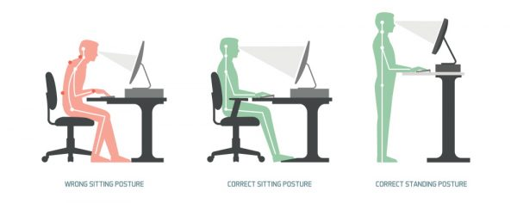







**When sitting or standing at your workstation be mindful of maintaining a good posture!**

**When sitting at your workstation your:**

* Head should be upright and over your shoulder.
* Eyes should be looking slightly downward (without bending neck).
* Back should be supported by the back rest of the chair which promotes the natural curve of the lower back.
* Elbows bent, forearms horizontal.
* Thighs horizonal.
* Feet fully supported and flat on the floor.

