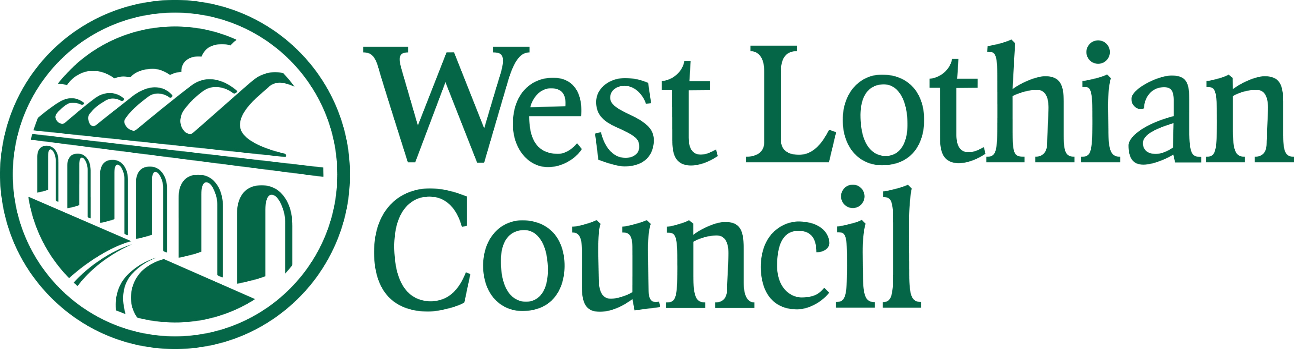

New Start Right to Work Verification Form (COVID-19)

This form should be used to document the right to work documentation checks that have been undertaken where original documents can not be viewed in person due to COVID-19 restrictions.

Verification of ID

Post Reference Number
Post Title
Candidate Name

- The candidate should submit a scanned copy or a photo of their original documents via email or using a mobile app to you
- At interview or via a subsequent video call with the candidate, ask them to hold up the original documents to the camera and check them against the digital copy of the documents
- Record the date you made the check below and return this form along with the digital copy of the documentation to recruitment@westlothian.gov.uk
- An offer of employment will not be processed until the completed form and documentation have been received

Right to Work Documentation Received | Date documents seen – adjusted check undertaken due to Covid 19
Passport

or
Full Birth Certificate & Proof of NI Number

VERIFIER
Print Name - | Designation:
Signature -

To be returned to - recruitment@westlothian.gov.uk

