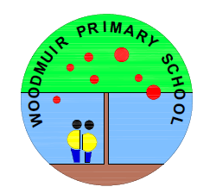

WOODMUIR SCHOOL
SCHOOL IMPROVEMENT PLAN
RECOVERY PHASE PLAN
2020 / 2021
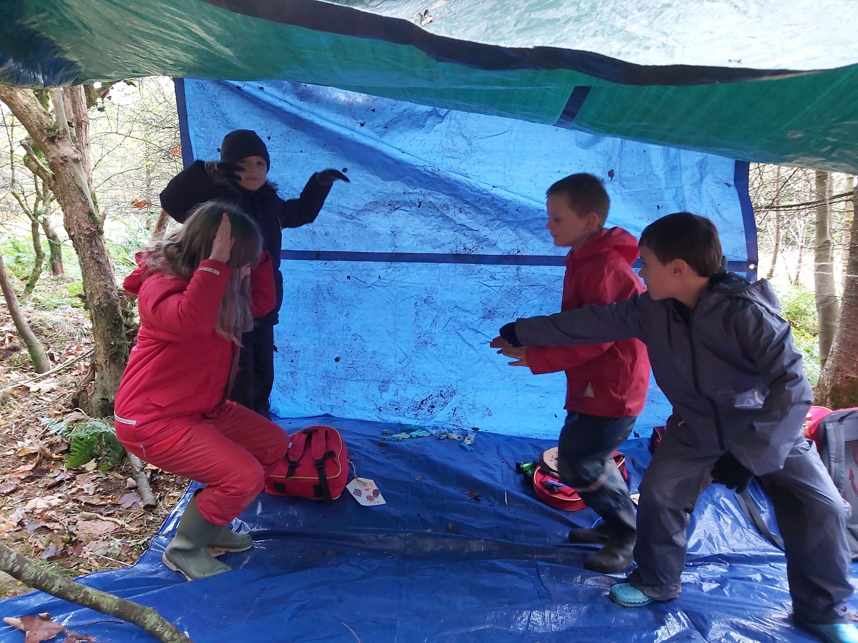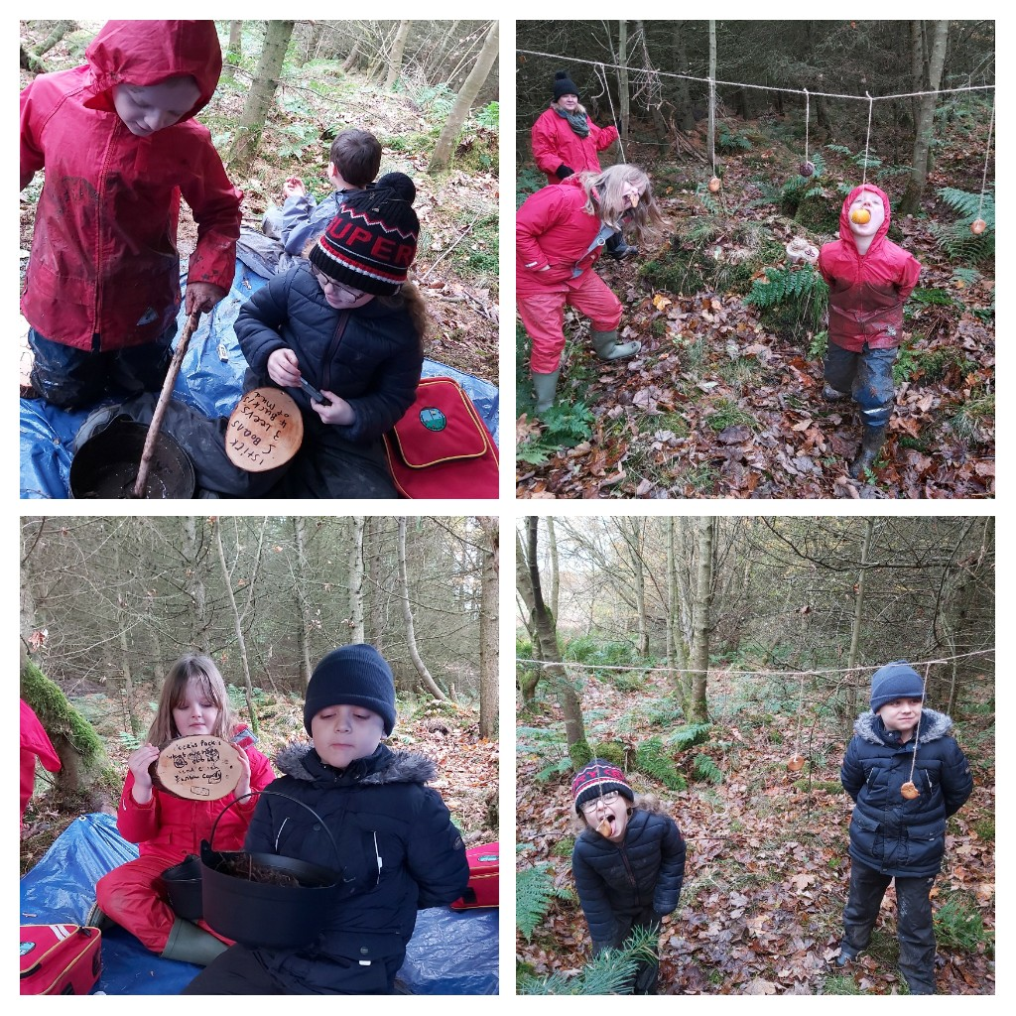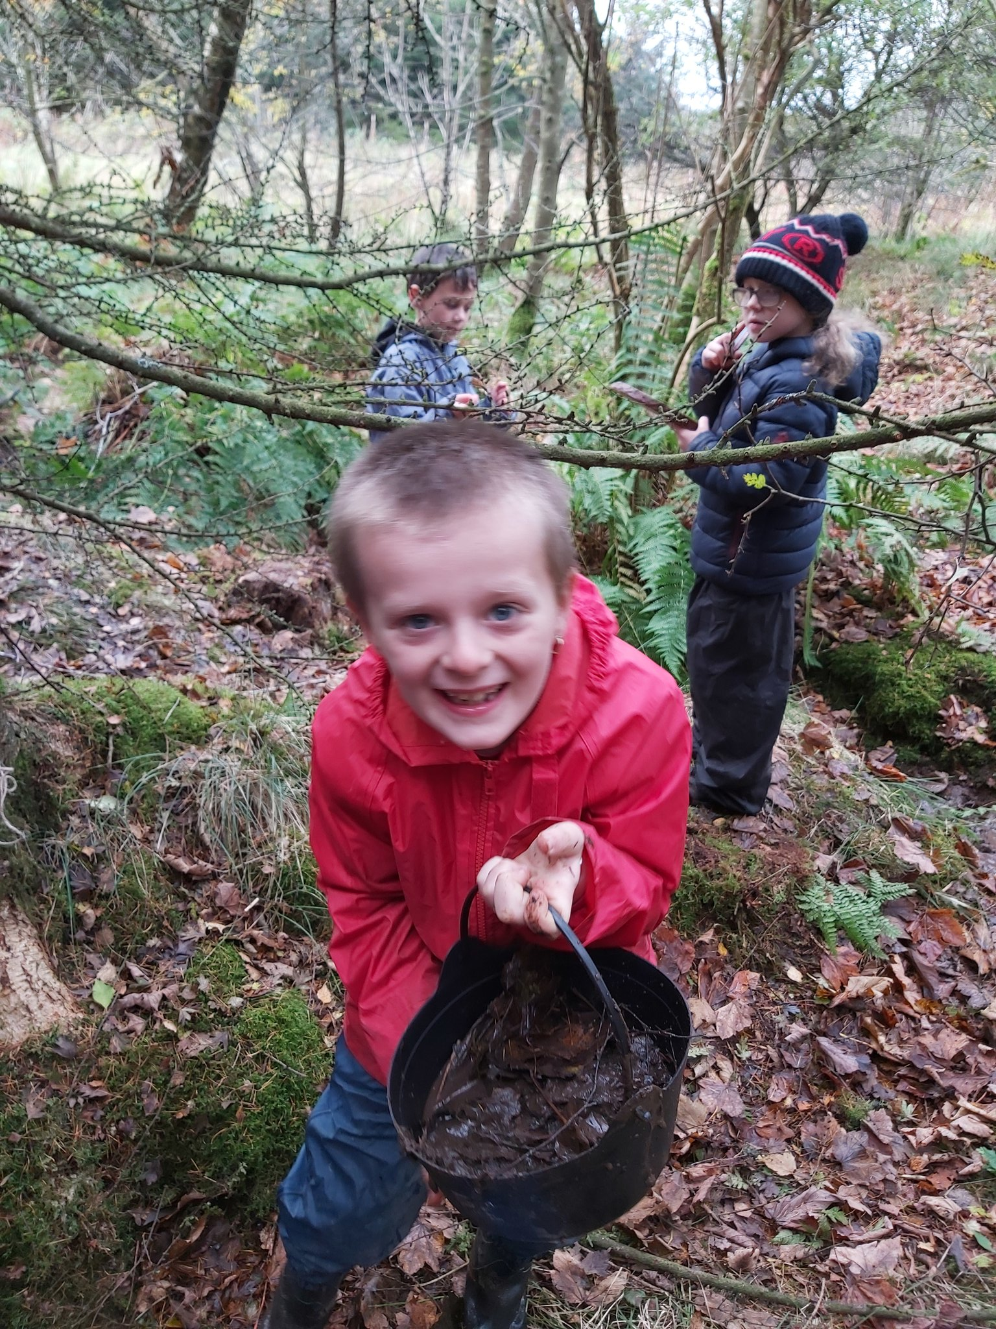
Factors Influencing the Improvement Plan
School Factors
Addressing Action Points identified in school’s Self Evaluation procedures
WCC Cluster Improvement Priorities
Flexible early learning and childcare implementation

Local Authority Factors
Moving Forward in Learning Guidance – Leadership for Improvement; Learning, Teaching and Assessment; Wellbeing and Inclusion; Early Years Framework
Raising attainment, including closing the gap (West Lothian Raising Attainment Strategy)
Transforming Your Council
Corporate Plan
Education Services Management Plan
West Lothian Parental Involvement and Engagement Framework
Continuation of Phased Implementation of 1140 hours ELC

National Factors
National Improvement Framework / Scottish Attainment Challenge / National Improvement Hub / Raising Attainment for All
Pupil Equity Funding
How Good is Our School? 4th Edition and How Good is Our Early Learning and Childcare?
National Standard for ELC
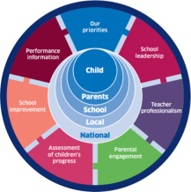
Getting it Right for Every child (GIRFEC)
Current Position

Next Steps
Curriculum for Excellence
Developing Scotland’s Young Workforce
Realising the Ambition
Child Protection Procedures
GTCS standards and professional update

Vision and Values and Aims

As a school community we have spent time revisiting our Values and Vision to ensure they are a true representation of who we are at Woodmuir and what we want for our learners. (Developed by pupils, staff, parents and community 2017/18).
Our core Values define and shape our school and form the foundation of our curriculum.

RESPECT CARE RESPONSIBILITY PERSEVERANCE COLLABORATION COMMUNITY EQUALITY

Our Aims:
- To ensure that Health and Wellbeing is at the centre of everything we do
- To celebrate diversity and ensure equality for all children
- To create a relevant and exciting curriculum to motivate and inspire children
- To provide high quality learning experiences in and out the classroom
- To form positive partnerships between pupils, teachers, parents and the local community
- To celebrate all children’s achievements both in and out of school
- To give children opportunities to develop leadership skills within school and the local community
- To have fun and have a love of Learning

Contextual Data Analysis and Rationale for 2020/21

The track 3 attainment for Woodmuir School shows that the majority of P1 pupils achieved Early Level Reading, Writing and Listening and Talking by the end of P1. The majority of pupils in P1 achieved Early Level Numeracy and Mathematics by the end of P1. By the end of P4 the majority of pupils achieved First Level Reading, Writing and Listening and Talking. By the end of P7 almost all pupils achieved Second Level Reading and Listening and Talking. Less than half of the P7 pupils achieved second Level Writing. Almost all P7 pupils achieved Second Level Numeracy and Mathematics.
In session 2020/21 we have a strong focus on developing reading and writing across the school in order to raise future attainment. All staff will be trained in Reciprocal Reading this session and will also further develop their understanding of our new writing programme.
As 72% of our children at Woodmuir are identified as having additional support needs, we have invested in additional staffing to support our children’s needs and to raise attainment in Literacy and Numeracy. Our PEF employed Pupil Support Worker will continue to work 4 afternoons per week on targeted interventions in Literacy and Numeracy. Our Acting PT will also support vulnerable pupils and pupils who have identified learning gaps. Our Pupil Support workers are also timetabled to support the delivery of targeted interventions in order to raise attainment.
During the lockdown period, almost all pupils in P4-P7 regularly engaged with the online learning through TEAMS. P1-P3 were sent weekly learning grids during the school closure and almost all pupils engaged with this learning. The feedback we received from families was very positive and they felt well supported at home. The pupils who were identified as not engaging with learning during the school closure were supported by staff members and given strategies and alternatives means to access their learning.

Wodmuir Primary School
Our Priorities
Health & Wellbeing
Teaching, Learning & Assessment
Literacy
Numeracy
Developing The Young Workforce
Digital Technologies

Values
Community
Belief
Love
Equality
Respect
Learning, Teaching & Assessment
Digital Technologies
Play Based Learning Revising approaches to teaching literacy
Interdisciplinary Learning
Agile Learning
Assessment
Moderation
Rules
Respect
Ready
Safe
Agile Learning
An agile learning culture aims to immerse young people in a learning environment in which they gain the skills, knowledge and adaptability to flourish.

Consider new possibilities
Developing the Young Workforce
Experiences which equip our learners with opportunities for their future.
Taking notice of changing needs and circumstances within our community and adapting our curriculum.
Learning Re-explored: The enduring, long-term aspiration for our pupils, communities and school.

No boundaries:
Learning is indoors, outdoors, at school, at home, online, local and global
Pupils Leading Learning
Self evaluation
Pupil as Leaders
Head Pupils
Learning Ambassadors
Staff CLPL
Self-Evaluation
Health & Wellbeing of All
Pupils self reporting and supported by their trusted adult.
Wider Achievements
Relationships are at the heart of everything we do.
Nurturing Approach
Shared Ownership: pupils, parents and teachers.
Motivation through engagement: interests, passions and initiative.
Skills centred approach
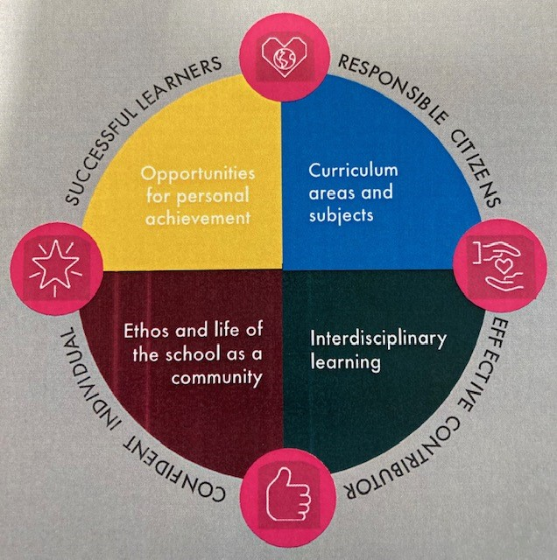
Recovery Curriculum Rationale

Woodmuir Primary School- School Improvement Planning (Recovery Phase) for Ensuring Excellence and Equity
School priorities linked to knowledge and data as identified on previous page | Proposed actions to ensure recovery | Timescale | Measures of Success
Improvement in all children and young people’s wellbeing:  Children’s health and wellbeing tracked regularly in order to provide ongoing support.  Children will feel safe, valued, respected and nurtured. | - Health and Wellbeing questionnaires completed by all pupils as a baseline assessment.  - All pupils self-reporting their wellbeing on a termly basis.  - All pupils have an identified one trusted adult and can request conversations with their adult when required.  - Interventions and action plans have been put in place for children who have identified as ‘red’ against the wellbeing indicators.  - Daily check- ins with the children using the ‘Colour Monster’.  - Continue to embed the emotion works programme across the curriculum. | Aug, 2020 – June, 2021 | Additional needs are recognised at an earlier stage in order to provide support for the children.  Most children will feel confident in being able to discuss sensitive issues with their one trusted adult.  Most children will make progress and have a clear understanding of the support they have in place.  Class teachers are able to identify individuals who are not ready to learn and put strategies in place.  Most children will have a better understanding of the wide range of emotion vocabulary and how emotions impact on their emotional and physical wellbeing.
Raising attainment for all, particularly in literacy and numeracy:  All children receive well-planned learning in Literacy and Numeracy which provides appropriate progression.  High quality learning experiences planned across the 4 contexts of Learning.  Continue to improve attainment in Numeracy | - Baseline assessments carried out in numeracy and literacy for all children in the school.  - Targeted interventions put in place to support gaps in learning.  - Focus on P2 and P5 children to ensure that they are still on track with their learning.  - Digital learning at home continued through TEAMS and seesaw for all children in the school.  - All digitally excluded children identified and logged.  - Continue to embed PM writing across the curriculum.  - All class teachers will undertake CLPL in reciprocal reading.  - Cluster moderation on writing to ensure shared standards and to support teacher professional judgement.  - Cluster literacy plan ensures writing is taught across all four contexts of learning and in a variety of genres.  - Initial focus on Literacy, Numeracy and Health and Wellbeing.  - Robust tracking and monitoring procedures in place to identify needs and put in support as required.  - Planned universal and targeted interventions to support identified children. | Aug, 2020 – June, 2021 | Class teachers will know where their children are in their literacy and numeracy learning and identify any learning gaps.  Most children will make progress through targeted interventions and there will be added value.  Most P2 and P5 children will be on track for their learning in Literacy and Numeracy.  A consistent approach in writing across the cluster.  All PEF children making steady progress and showing added value.
Closing the attainment gap between the most and least advantaged children:  Targeted interventions in literacy and numeracy across the school. |  | Aug, 2020 –June, 2021
Improvement in employability skills and sustained, positive school leaver destinations for all young people:  To embed the Career Education Standard in all aspects of the curriculum | - Introduce skills for learning, life and work across the curriculum.  - IDL planners will include opportunities for application of literacy, numeracy and health and wellbeing across learning.  - Transferable and higher order thinking skills will be developed through IDL learning.  - Digital literacy continued to be developed across the school.  - Continue to develop profiling in Health and Wellbeing  - STEM lead in the school leading initiatives. | Aug 2020 – June 2021 | Most children will be able to talk about the skills they use across the curriculum and how they relate to life of work.  Pupils will develop digital literacy skills at all stages.

