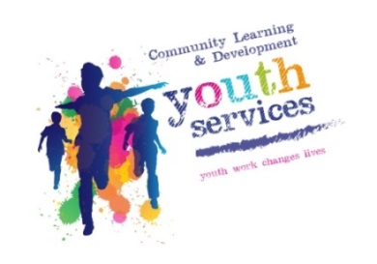

Community Learning and Development - Youth Services - Armadale Partnership Centre
Armadale Activity Holiday Lunch Club - Easter 2019
Age range - P1 – P7 Pupils educated / resident in the Armadale Area.
Dates and times –
Monday 8th April 2019 – 10.15am – 1pm Monday 15th April 2019 – 10.15am – 1pm
Tuesday 9th April 2019 – 10.15am – 1pm Tuesday 16th April 2019 – 10.15am – 1pm
Wednesday 10th April 2019 – 10.15am – 1pm Wednesday 17th April 2019 – 10.15am – 1pm
Thursday 11th April 2019 – 10.15am – 1pm Thursday 18th April 2019 – 10.15am – 1pm
Friday 12th April 2019 – 10.15am – 1pm Friday 19th April Good Friday programme off today!
Join us for an Easter eggstravigansa! Come and join our fun packed activity programme!
We will be doing Easter themed activities, sports, arts and crafts and looking at science! We will end our programme with an Easter themed disco.
Please note children must be dropped off and collected by Parent /Guardian.
Venue – Armadale Partnership Centre, 7 North Street, Armadale, West Lothian, EH48 3QB.
Cost - £1.00 per day (A hot lunch is included free of charge!)
To Register - For further information and to register please come into Armadale Partnership reception to book
a space with Claire Carbray on Monday 1st April between 10am – 4pm.
Activities include – Sports, arts and crafts, egg rolling and a disco!
Please note - There are 50 spaces per day maximum and it will be allocated on a first come first served basis.
Parents look out for our March group texts from your school reminding you of the sign up date above.
For more information contact your local Community Education Worker - Claire Carbray on 01506 283045 or 07990788029

