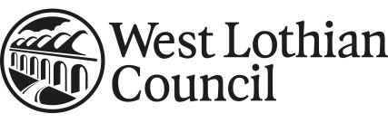

|  |  |
| --- | --- |
|  |  |

|  |
| --- |
| **REGISTER 5 - EMPLOYEE’S ACCEPTANCE** OF OFFER OF GIFTS AND HOSPITALITYDECLARATION/ACCEPTANCE FORM |
| Name of employee receiving offer: |
| Service Unit: |
| Name of person making offer: |
| Company/body represented: |
| Date offer received: |
| Details of gift or hospitality offered |
|  |
|  |
|  |
|  |
| Estimated Value: |

|  |  |
| --- | --- |
| Employee’s Signature: | Date: |

|  |  |
| --- | --- |
| **AUTHORITY TO ACCEPT OFFER** | |
| Line Manager’s Name (please PRINT): | |
| Designation: | |
| Line Manager’s Signature: | Date: |

|  |
| --- |
| Details of how accepted gift is used |
|  |
|  |
|  |
|  |

***Examples of when the form should be used:***

*An employee is offered a bottle of whisky as a thank you from a member of the public who*

*has been in receipt of council services OR an offer of hospitality from a partner organisation*

*to attend an award ceremony.*

Details of how the council will process the personal information it holds on you can be found at <https://www.westlothian.gov.uk/media/20843/Contract-of-Employment---Privacy-Notice/pdf/2018-03-21_-_Contract_of_Employment_Privacy_Notice.pdf>