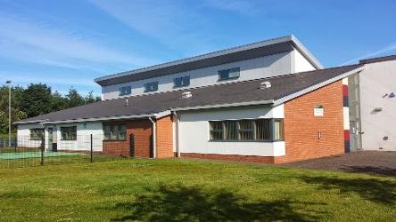

**Monthly Meetings**

***Management Committee - Gala Day Committee***

**Facilities and Resources**

* Function hall capacity for 100 people
* Meeting rooms varying sizes
* Playgroup room
* IT Suite
* Multi use outside games area suitable for football and basketball
* Disabled parking
* Baby changing area

***Halls available to book for Events, Activities and Parties***

**Service Support Officer Community Facilities Assistants**

**Sandra McLaughlin Craig Pennycook Festus Amadin**

**07771 864 513 Ben Slattery James Welsh**

**Andy Rintoul**

**Monday**

Gentle Exercise Class 9.00a.m – 10. 00a.m

Playgroup 9.00a.m – 2.30p.m

NHS Pain Management 1.00p.m - 4.00p.m

Rainbows/Brownies/Guides 6.00p.m – 9.00p.m

Craft Club 7.00p.m – 9.00p.m

**Tuesday**

Playgroup 9. 00a.m – 2. 30p.m

Craft Club 10. 00a.m – 12.00p.m

Beavers 6. 30p.m – 7.30p.m

Art Club 7. 00p.m – 9.00p.m

**Wednesday**

Playgroup 9. 00a.m – 2. 30a.m

Adult Learning 10.00a.m – 12.00p.m

Kids Club 3. 30p.m – 5. 30p.m

**Thursday**

Playgroup 9. 00a.m – 2. 30p.m Line Dancing 1. 00p.m – 4.00p.m

Rainbows 6.00p.m – 7.00p.m

Cubs/Scouts 6. 30p.m – 9. 15p.m

**Friday**

Gentle Exercise Class 9.00a.m – 10.00a.m

Playgroup 9. 30a.m – 11. 30a.m

Fizzy Dance 3. 00p.m – 6. 00p.m

Karate 6. 30p.m – 7. 30p.m

Flamenco Dance Class 6.30p.m – 7.30p.m

**Saturday** Baby Ballet 9. 15a.m – 11. 45a.m

Castanets Class 12.00p.m – 1.00p.m

**Livingston Station Community Centre 2025 Programme**

Livingston Station Community Centre, 4 Main Street, Deans, Livingston, West Lothian

**Tel: 01506 411295 Email: sandra.mclaughlin@westlothian.gov.uk**

**These facilities are available for booking from 8:00am until 10:00pm**

**seven days a week**