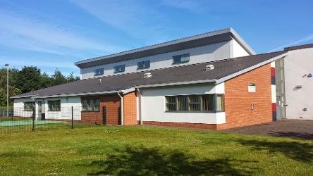

**Monthly Meetings**

***Management Committee - Gala Day Committee***

**Facilities and Resources**

* Function hall capacity for 100 people
* Meeting rooms varying sizes
* Playgroup room
* IT suite
* Multi use outside games area suitable for football and basketball
* Disabled parking
* Baby changing area

***Halls available for let for Events, Activities and Parties***

**Service Support Officer Community Facilities Assistants**

**Sandra McLaughlin Craig Pennycook Festus Amadin**

**07771 864 513 Ben Slattery James Welsh**

**Andy Rintoul**

**Monday** Gentle Exercise Class 9.00a.m – 10. 00a.m

Playgroup 9.30a.m – 11.30a.m

HYPE 10.00a.m – 3. 00p.m

NHS Pain Management 1.00p.m - 4.00p.m

HYPE 5.30p.m – 9.00p.m

Rainbows/Brownies/Guides 6.00p.m – 9.00p.m

Cardmaking Club 7.00p.m – 9.00p.m

**Tuesday** Playgroup 9. 30a.m – 11. 30a.m

Parents & Toddlers 10. 00a.m – 11. 30a.m

Card Making Club 10. 00a.m – 12.00p.m

HYPE 10. 00a.m – 3.00p.m

Sure Start 12.15p.m – 3.15p.m

Beavers 6. 30p.m – 7.30p.m

Art Club 7. 00p.m – 9.00p.m

**Wednesday** Fitness Class 9.20a.m – 10.20a.m

Playgroup 9. 30a.m – 11. 30a.m

HYPE 10.00a.m – 3.00p.m

Singing for Health 2.30p.m – 4.00p.m

Kids Club 3. 30p.m – 5. 30p.m

Junior Youth Club 6. 30p.m – 8. 30p.m Karate 7. 30p.m – 8. 30p.m

**Thursday** Playgroup 9. 30a.m – 11. 30a.m

Parents & Toddlers 10. 00a.m –11. 30a.m Line Dancing 1. 30p.m – 3. 30p.m

Rainbows 6.00p.m – 7.00p.m

Cubs/Scouts 6. 30p.m – 9. 15p.m

**Friday** Gentle Exercise Class 9.00a.m – 10.00a.m

Playgroup 9. 30a.m – 11. 30a.m

HYPE 9. 00a.m – 4. 30p.m

Fizzy Dance 3. 00p.m – 6. 00p.m

Karate 6. 30p.m – 7. 30p.m

Come-all-ye Folk Night 7.00p.m – 9.45p.m

(1st Friday of the Month)

**Saturday** Baby Ballet 9. 15a.m – 11. 45a.m

Bricks Club UK 10.30a.m- 12.30p.m

**Livingston Station Community Centre 2024 Programme**

Livingston Station Community Centre, 4 Main Street, Deans, Livingston, West Lothian

**Tel: 01506 411295 Email: sandra.mclaughlin@westlothian.gov.uk**

**These facilities are available for booking from 8:00am until 10:00pm**

**seven days a week**